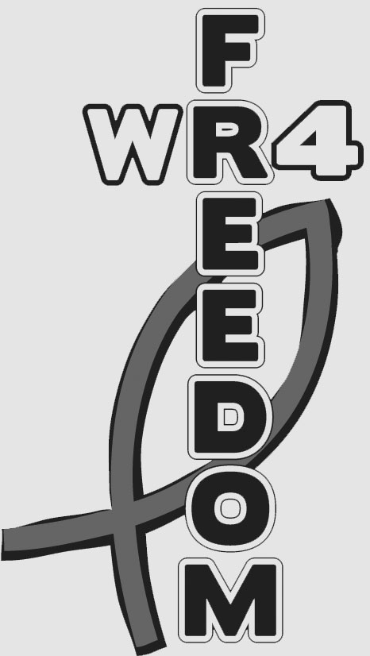

***Fee:***  $10 per entry  
$10 optional t-shirt  
*(check website for group rates and rate after 9/7/13)*

***For more information or   
to register go to:***

*www.walkrun4freedom.weebly.com*

Registration is online at:

*www.walkrun4freedom.weebly.com*

Feel free to like us on Facebook!

***Where:*** Pennsy Trail,   
Greenfield, IN  
*(Start/Finish line just behind the Greenfield Courthouse Plaza)*

***When:*** September 21, 2013  
9:00 a.m.  
  
  
@ 9:00 A.M.

***What:*** 4 Mile Walk/Run 4 Freedom *(1 mile option) available)*

***Human Trafficking Facts:***

* $32 billion industry, more than Apple ($26.7 billion) and Starbucks ($10.7 billion)
* Affects 161 countries worldwide
* 100,000 to 300,000 U.S. children are trafficked each year

***Goal:*** To bring awareness to the Human Trafficking epidemic AND to raise $10,000 to benefit Rapha House. *(This will provide 3 girls complete care for 1 year.)*

***Rapha House:*** An organization that is working to combat human trafficking. Their goal is to help girls achieve lasting freedom from a desperate future by providing education, vocational training, care, and counseling.